Lasalle College

Grid Storm

Derick Esguerra

Jesten Auger

Lorenzo Picken

Team:

Derick Esguerra: Gameplay Programmer

Jesten Auger: Game Designer, level design, gameplay programer

Lorenzo Picken: Gameplay Programmer

Game Title: Grid Storm

Tagline: Where light is your weapon, and the Grid is the battlefield.

Genre: Action, FPS, Multiplayer, Battle Royal

Major Mechanics Description:

A 16-player multiplayer battle royal, the game will last until a player wins 3 times in a row. The core gameplay of the game centers around players fighting over powerful loot and power ups in order to win the round. Every player has access to 2 dash and fast movement speed, they will also start with a basic pistol, the loot and powerups gained will determine the combat prowess of each individual. As such, the win conditions of every round is to grow your strength and overpower them.

Design: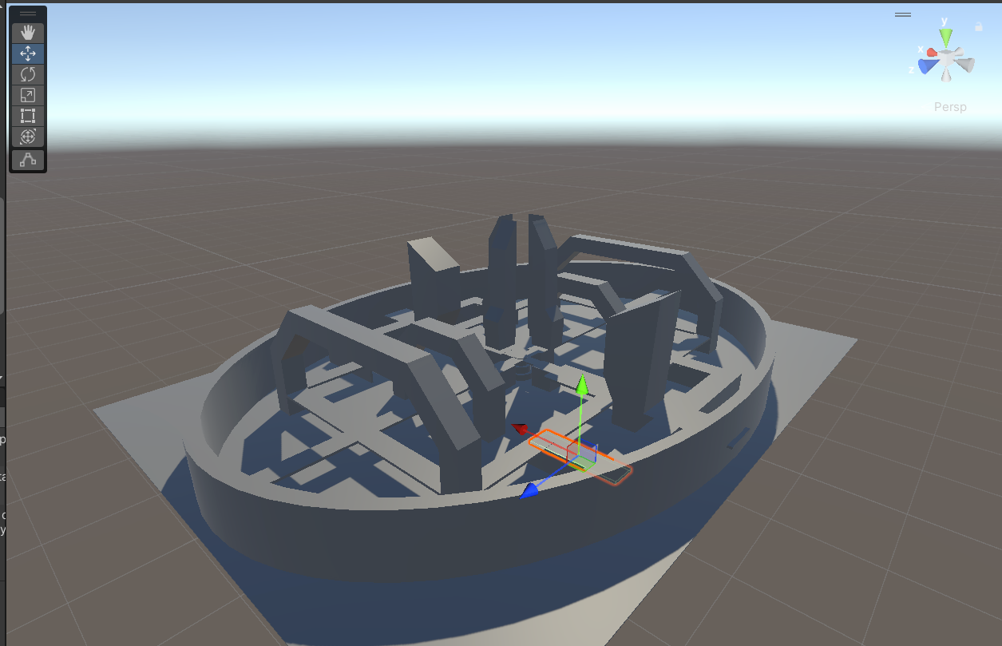

Inspirations:

Tron

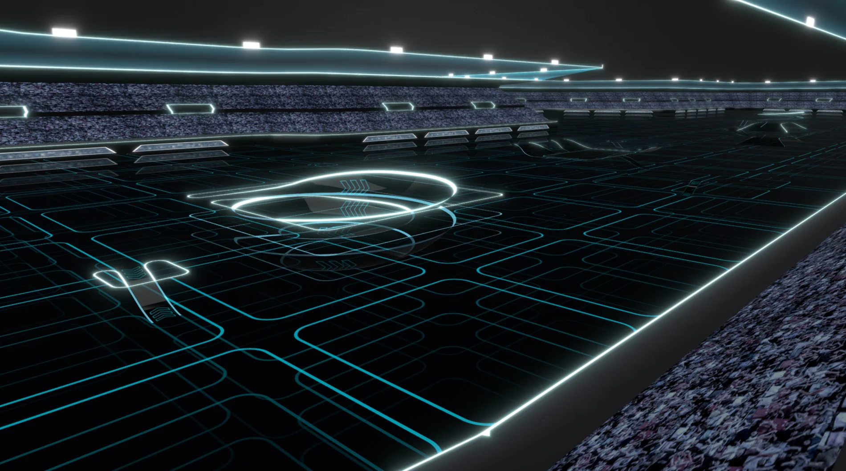

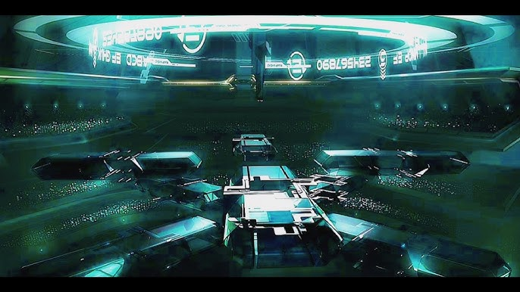

Doom Eternal:

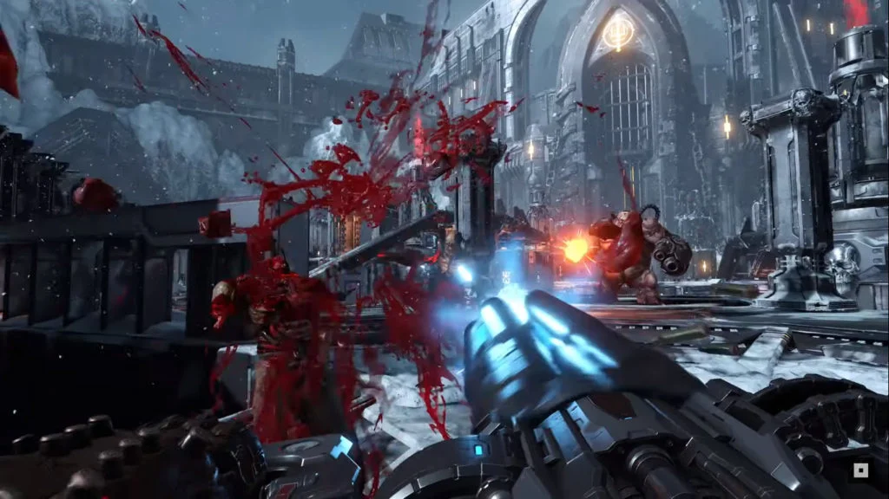

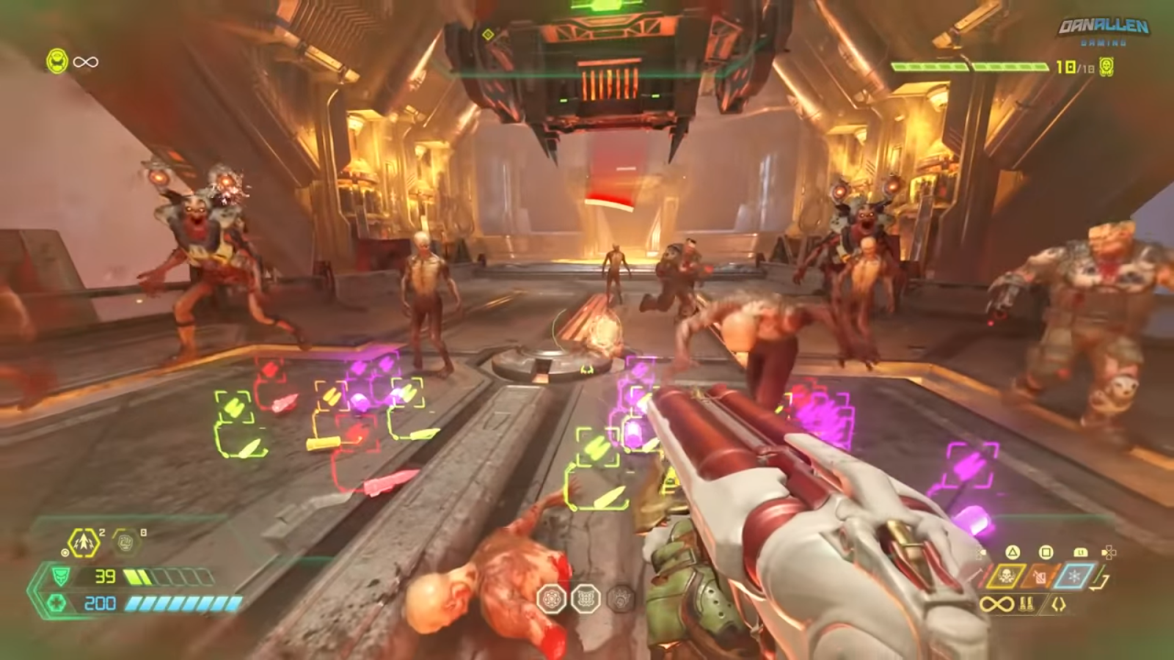

Delivery 1:

Lorenzo Task:

* Player Control
* Multiplayer Capabilities

Jesten Task:

* Design Map
* SFX
* Health system

Derick Task:

* PowerUps
* Weapons Randomizer
* Pause Menu

Delivery 2:

Lorenzo Task:

* Synching player data
* Gunplay

Jesten Task:

* Design Map
* Design Weapons

Derick Task:

* Work on Damage System
* Scoreboard